***Computer Organization***

**Lab 5 Report**

***Names:***

**عبد الرحمن إسماعيل محمد حسن (22010866)**

**نور الدين اكرم السيد كامل سيف (22011309)**

**Introduction**

This project demonstrates the use of a software debugger (Virtual Micro) to debug hardware (Arduino Uno).

**Implementation Setup**

* Arduino UNO microcontroller board.
* 6-Pin switch button (latch) for changing LED state.
* Jumper wires for circuit connections.
* Breadboard for building the circuit.
* Visual Studio IDE for programming the microcontroller and Virtual Micro extension for debugging.

**Implementation Details**

* The Arduino built in LED is used.
* The Arduino continuously reads the digital input from the latch.
* The latch value determines the state of the LED, if the latch is pushed down the LED will be on, if the latch is pulled up the LED will be off.
* If the LED changes its state from on to off or from off to on then the execution of the code stops and the debugger prints out the current state of the LED.
* The execution does not continue until the “Continue/Step” button of Visual Micro is pressed.

**Screenshots**

Off to On State

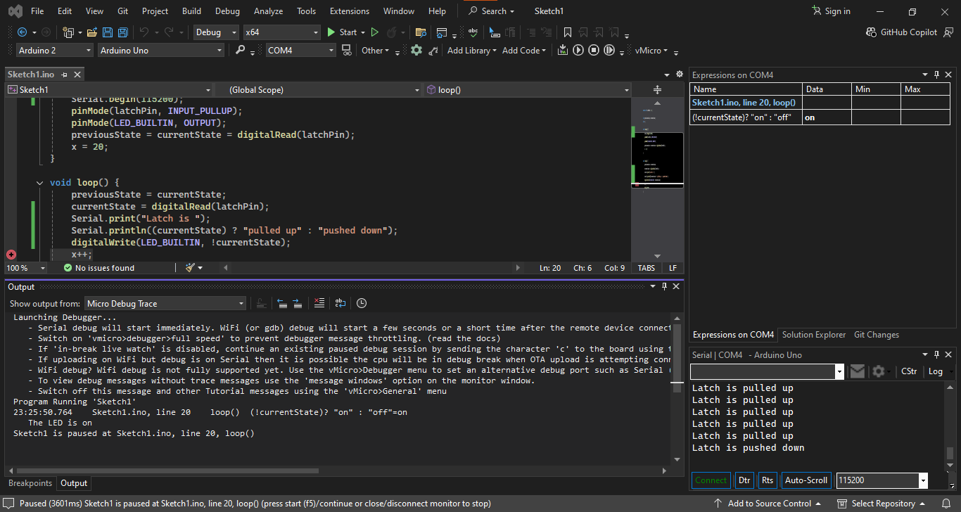

On to Off State

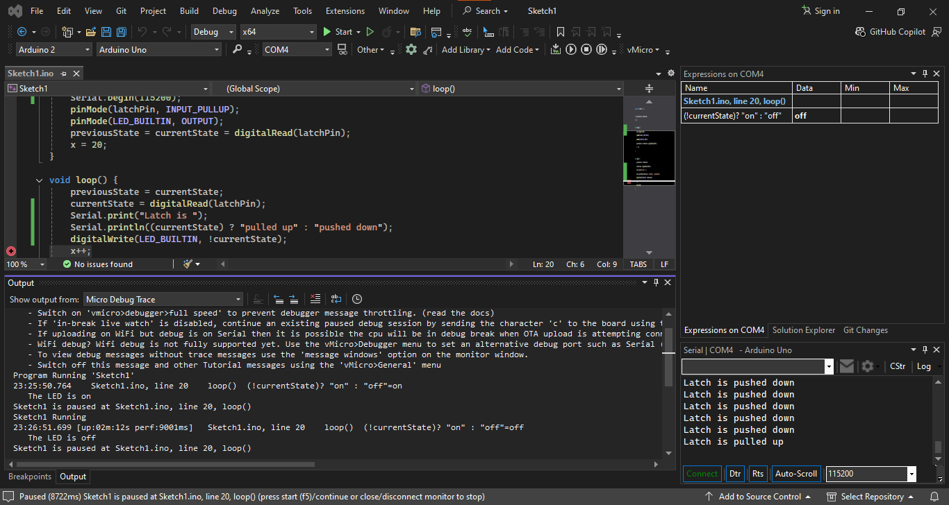

**Circuit Layout Diagram**

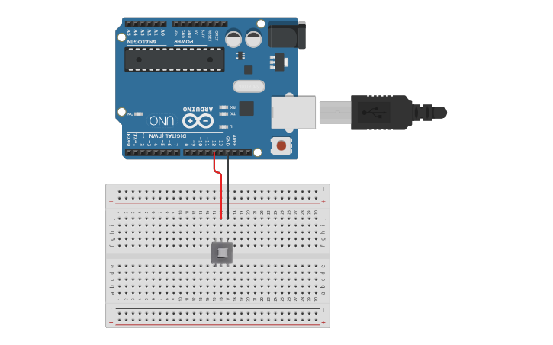

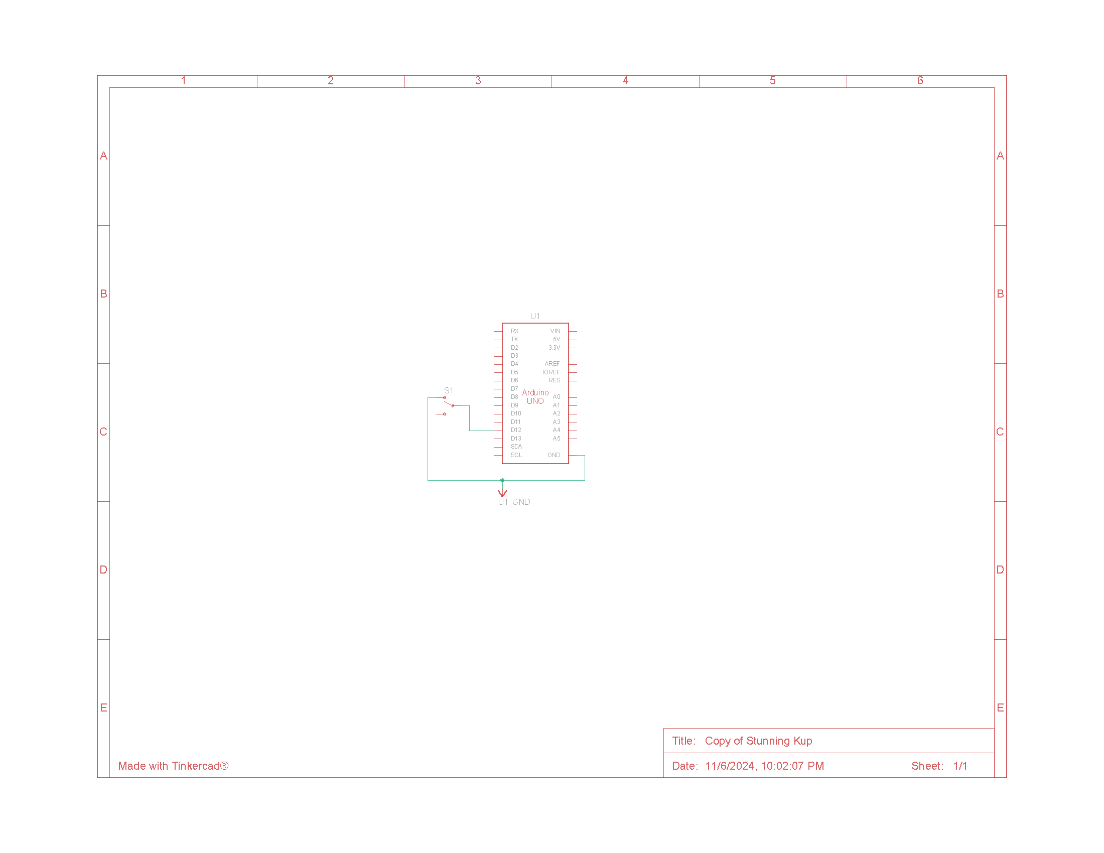**Circuit Schematic Diagram**